**Help for sleep problems**

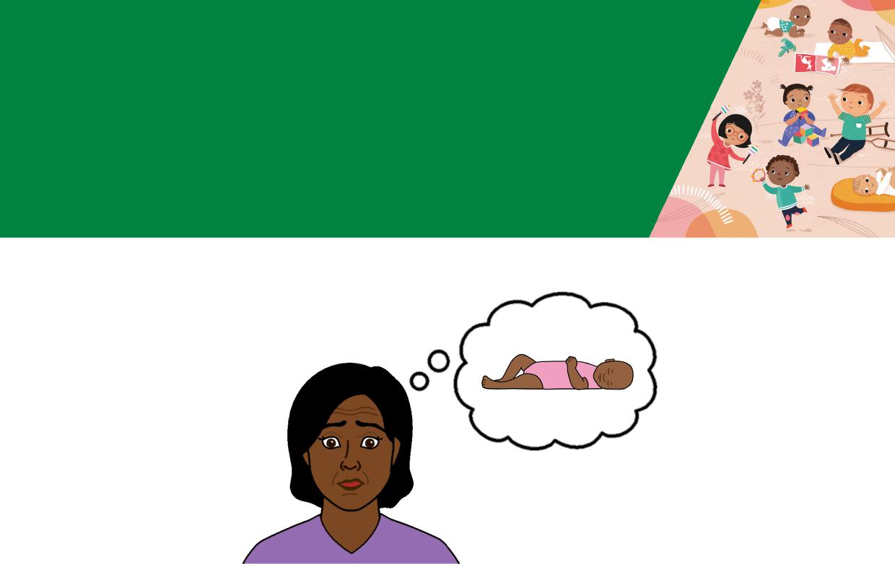

**Babies 6 - 12 months**



**Easy English**



Hard words

|  |  |
| --- | --- |
|  | This book has some hard words. |

The first time we write a hard word

* the word is in blue
* we write what the hard word means.

You can get help with this book

|  |  |
| --- | --- |
|  | You can get someone to help you   * read this book * know what this book is about * find more information. |
|  |

Page 2

**About this book**

|  |  |  |
| --- | --- | --- |
|  |  | This book is written by the Department of Health. |
|
|  |

|  |  |
| --- | --- |
|  | This book tells you about help for sleep  problems in babies aged **6 - 12** months. |

Page 3

**Severe night waking**

**Severe night waking** means your baby



* wakes up more than 3 times per night
* stays awake for more than 20 minutes

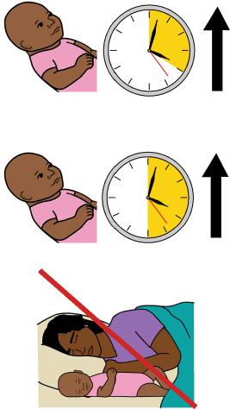

* takes more than 30 minutes to settle
* needs to sleep in bed with you.

|  |  |
| --- | --- |
|  | If your baby will **not** stop crying and you are tired   * take a break for 3 - 5 minutes |

|  |  |
| --- | --- |
|  | * put your baby in the cot where they can cry in a safe place. |

You must rest and look after yourself too.

Page 4

**Help with sleep concerns**

|  |  |
| --- | --- |
|  | To help your baby sleep make sure you   * notice the things they do when they are tired |

|  |  |
| --- | --- |
|  | * put your baby in the cot when you think they are tired |

|  |  |
| --- | --- |
|  | * keep the room dark and quiet every night. |

|  |  |
| --- | --- |
|  | * do things in the same order every day   before sleep time.  For example  – feed  – play  – sleep. |

Page 5

|  |  |
| --- | --- |
|  | **Parental presence**  **Parental presence** can help your baby sleep.  Parental presence means you pretend to sleep in the room with your baby. |
|  | Make sure your baby can see you when you pretend to sleep. For example, lie next to the cot with a night light. |

|  |  |
| --- | --- |
|  | If your baby wakes up, make some noise so they know you are there.  If your baby does **not** go back to sleep   * do **not** pick up your baby * try a gentle shush or pats * after 2 minutes pretend to be asleep again. |
|  |

Page 6

|  |  |
| --- | --- |
|  | You can use parental presence for day time naps too. |

|  |  |
| --- | --- |
|  | You can **stop** parental presence when your baby sleeps well for 3 days in a row. |

Page 7

**Camping out**

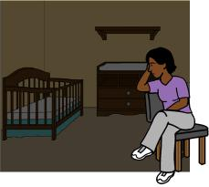

Camping out means you

* stay in the room until your baby sleeps
* leave your baby to sleep on their own

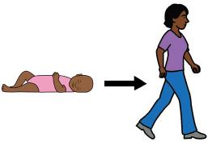

* do **not** sleep in the room

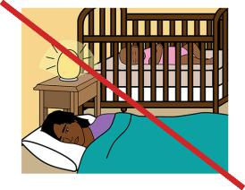

Page 8

Use camping out in steps.

|  |  |
| --- | --- |
|  | 1. Try gentle pats until your baby sleeps. |

|  |  |
| --- | --- |
|  | 2. Sit in a chair next to the cot until your baby sleeps - do **not** touch your baby.  3. Move your chair a bit more away from the cot each day. |

4. Move your chair outside the door.

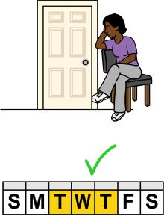

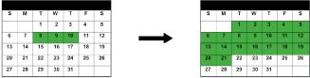

Each step might take 2 - 3 days to work.

It might take 1 - 3 weeks for your baby to go to sleep without you in the room.

Page 9

**Responsive settling**

|  |  |
| --- | --- |
|  | **Responsive settling** is a way to help your baby go to sleep. |
|  | You try to understand what your baby needs.  For example, if your baby   * is tired and needs to go to sleep * needs comfort and support. |

Page 10

**The steps to responsive settling**

|  |  |
| --- | --- |
|  | 1. Calm your baby before bedtime. |

1. Put your sleepy baby on their back in their cot.
2. Be calm and use slow movements.
3. Let your baby see your face and say **sshh sshh**.



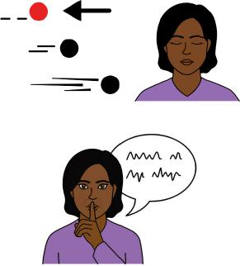

|  |  |
| --- | --- |
|  | 5. Move to a place where your baby cannot see you.  6. Stay in the room to let your baby settle. |

Page 11

What to do if your baby starts

to cry

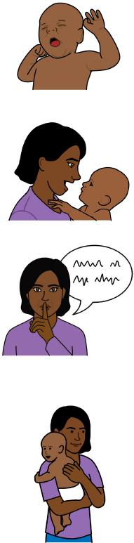

Your baby will cry if they need your support.

Show your baby your face if they start to cry.

Speak quietly and say sshh sshh   
or it’s time for sleep.

Put your hands on your baby to help them feel safe.

|  |  |
| --- | --- |
|  | Encourage your baby to lie down if they are standing in the cot. |

|  |  |
| --- | --- |
|  | You can put your baby on their back if they will not lie down. |

Page 12

|  |  |
| --- | --- |
|  | Try another way to put your baby to sleep if you think your baby   * has had enough of what you have tried * is very upset * will not calm down.   You can try responsive settling the next time your baby needs to sleep. |

|  |  |
| --- | --- |
|  | You **must** leave your baby in the cot and walk away if you feel angry. |

|  |  |
| --- | --- |
|  | It takes time for your baby to learn how to settle down and go to sleep. |

Page 13

**More information**

For more information contact the Department of Health.

|  |  |
| --- | --- |
|  | Website  <https://www.betterhealth.vic.gov.au/healthyliving/child-health-0-6> |

If you are worried about your baby



* contact your Maternal and Child Health Nurse
* call the Maternal and Child Health Line. Call 13 22 29

The helpline is open 24 hours per day and 7 days per week.

You can also see your doctor for more help.

Page 14

**More Easy English**

|  |  |
| --- | --- |
|  | There are more Easy English books on our website about   * sleep for babies |

|  |  |
| --- | --- |
|  | * good sleep routines. |

|  |  |
| --- | --- |
|  | For information about safe sleep go to the Red Nose website  <https://rednose.org.au/section/safe-sleeping> |

|  |  |
| --- | --- |
|  | For information about getting to know your child go to the Raising Children website [raisingchildren.net.au/toddlers/connecting-communicating/connecting/parent-child-relationships](http://raisingchildren.net.au/toddlers/connecting-communicating/connecting/parent-child-relationships) |

Page 15

|  |  |
| --- | --- |
|  | **If you need help to speak or listen**  You can use the National Relay Service or  NRS if you need help to make a call. |

|  |  |
| --- | --- |
|  | Call the NRS help desk  1800 555 660  Go to the NRS website  [www.accesshub.gov.au/about-the-nrs](http://www.accesshub.gov.au/about-the-nrs) |

Page 16

**Notes**

Page 17

**Notes**

Page 18

Page 19

To receive this publication in an accessible format email Maternal and Child Health and Parenting: [MCH@health.vic.gov.au](mailto:MCH@health.vic.gov.au).



Authorised and published by the Victorian Government, 1 Treasury Place, Melbourne.

© State of Victoria, Australia, Department of Health, May 2024.

**ISBN** 978-1-76069-222-3

Available at <https://www.betterhealth.vic.gov.au/healthyliving/Child-health-0-6> (pdf/online).

Certain text, images and information incorporated in this publication were created by Scope (Aust) Ltd at [www.scopeaust.org.au](http://www.scopeaust.org.au) and Tobii Dynavox.

Scope (Aust) Ltd produced this Easy English version with the Department of Health in May 2024. The ‘Easy English’ style of writing is © Scope (Aust) Ltd 2024 (“Clear Written Communications - The Easy English Style Guide”). All Rights Reserved Worldwide. To contact Scope about its Easy English style of writing and its services call 1300 472 673 or visit [www.scopeaust.org.au](http://www.scopeaust.org.au)

The following materials contained in this document are not licensed to the State of Victoria, Australia,

Department of Health (‘excluded materials’):

- PCS is a trademark of Tobii Dynavox, LLC. All rights reserved. Used with permission. This document must not

be sold to third parties. The images must not be reused without permission.

- Certain other images and photographs (as marked).

Permission must be obtained from Tobii Dynavox or any other relevant third parties (as applicable) to use, copy,

reproduce, digitise, adapt, modify, communicate or publish any part of the above excluded materials.