**Help for sleep problems**

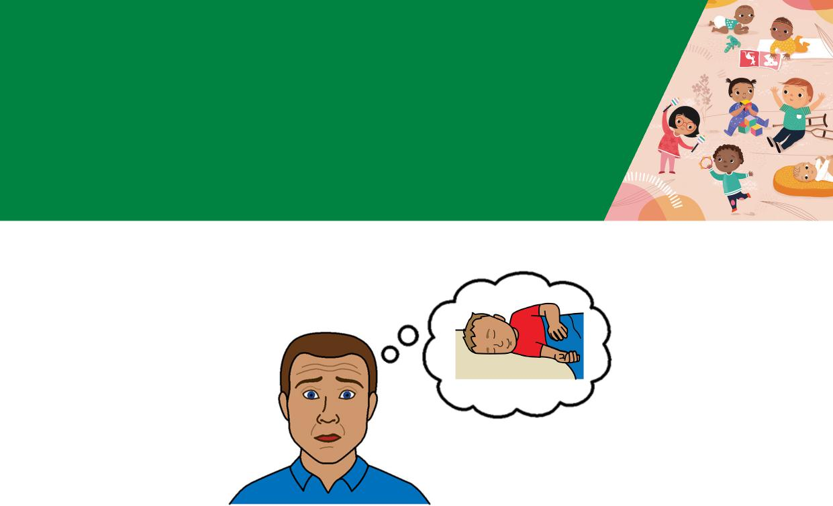

**Toddlers 1 - 3 years**



**Easy English**

|  |  |
| --- | --- |
|  | **Hard words**  This book has some hard words.  The first time we write a hard word |

* the word is in **blue**
* we write what the hard word means.

**You can get help with this book**

|  |  |
| --- | --- |
|  | You can get someone to help you   * read this book * know what this book is about * find more information. |
|  |

Page 2

**About this book**

|  |  |
| --- | --- |
|  | This book is written by the  Department of Health. |

|  |  |
| --- | --- |
|  | This book tells you about help for  **sleep problems** in toddlers aged **1 - 3** years. |

Page 3

**Severe night waking**

Severe night waking means your toddler



* wakes up more than 3 times per night
* stays awake for more than 20 minutes

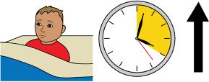

* takes more than 30 minutes to settle

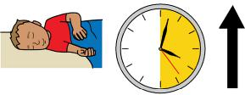

* needs to sleep in bed with you.

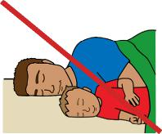

Page 4

**Help with sleep problems**

|  |  |
| --- | --- |
|  | To help your toddler sleep make sure you   * notice the things they do when they are tired |

|  |  |
| --- | --- |
|  | * put your toddler in bed when you think they are tired |

|  |  |
| --- | --- |
|  | * do things in the same order every day before sleep time |

|  |  |
| --- | --- |
|  | * keep the setting for sleep time the same.  For example, make it dark and quiet. |

Page 5

**Parental presence**

|  |  |
| --- | --- |
|  | **Parental presence** means you pretend to sleep in the same room as your toddler to make them feel safe. |

|  |  |
| --- | --- |
|  | Make sure your toddler can see you when you pretend to sleep. For example, lie next to the cot or toddler bed with a night light.  Every time your toddler wakes up, make some noise so they know you are there.  If your toddler does **not** go back to sleep   * do **not** pick up your toddler |
|  | * try a gentle shush or pats * after 2 minutes go back to your bed and pretend to sleep. |

Page 6

|  |  |
| --- | --- |
|  | You can use parental presence for day time naps too. |

|  |  |
| --- | --- |
|  | It might take 7 - 10 days for parental presence to work. |

|  |  |
| --- | --- |
|  | You can go back to your own room when your toddler sleeps well for 3 days in a row. |

|  |  |
| --- | --- |
|  | **Camping out**  Camping out means you   * stay in the room until your toddler sleeps * leave your toddler to sleep on their own * do **not** sleep in the room. |

Page 7

|  |  |
| --- | --- |
|  | Use camping out in steps.  For example  1 Try gentle pats until your toddler sleeps.  2 Sit in a chair next to the bed until your toddler sleeps. Do **not** touch your toddler. |

|  |  |
| --- | --- |
|  | 3 Move your chair a bit more away from the bed each day. |
|  | 4 Move your chair outside the door.    Each step might take 2 - 3 days to work.  It might take 1 - 3 weeks for your toddler to go to sleep without you in the room. |

Page 8

|  |  |
| --- | --- |
|  | **Responsive settling**  **Responsive settling** is a way to help your toddler go to sleep.  You try to understand what your toddler needs.  For example, if your toddler   * is tired and needs to go to sleep * needs comfort and support. |

Page 9

**The steps to responsive settling**

1. Calm your toddler before bedtime.

- For example, cuddle your toddler or sing to them.

1. Help your toddler get into their bed.
2. Give your toddler a sleep message like **good night** or **it’s time for sleep**.
3. Leave the room before your toddler goes to sleep.

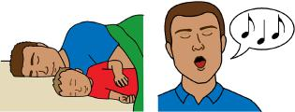

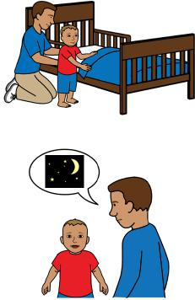

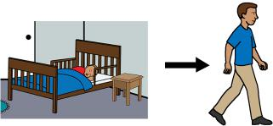

|  |  |
| --- | --- |
|  | 5. Stay outside the room to hear if your toddler settles. |

Page 10

|  |  |
| --- | --- |
|  | 6. Comfort your toddler if they get upset and cry.  - You might have to comfort your toddler many times before they settle. |

|  |  |
| --- | --- |
|  | Comfort your toddler if   * you think they have had enough * they remain upset   You **must** leave your toddler in the bed and walk away if you feel angry. |

|  |  |
| --- | --- |
|  | It takes time for your toddler to learn how to settle down and go to sleep. |

Page 11

Bed time fading

Bed time fading can help your toddler sleep.

Follow these steps for bed time fading.

|  |  |
| --- | --- |
|  | 1. Write down the time when your toddler falls asleep for 7 nights in a row. |

|  |  |
| --- | --- |
|  | 2. Find the latest time your toddler went to  sleep  in 7 nights and make it the new bed time. |

|  |  |
| --- | --- |
|  | 3. Make bed time 15 minutes later every 2 days. |

|  |  |
| --- | --- |
|  | 4. Stop fading when your toddler goes to sleep on their own and does not wake up a lot at night. |

Page 12

|  |  |
| --- | --- |
|  | Make sure your toddler is 2 - 3 years old before you use bed time fading.  You can use bed time fading to make bed time earlier too. |

|  |  |
| --- | --- |
|  | Talk to your Maternal and Child Health Nurse before you try bed time fading. |

Page 13

**Move your toddler to a bed**

|  |  |
| --- | --- |
|  | You can move your toddler to a bed if they try to get out of the cot. |

|  |  |
| --- | --- |
|  | To help your toddler move to a bed   * give your toddler a blanket from the cot so they feel safe |

|  |  |
| --- | --- |
|  | * do things in the same order every day before sleep time |

|  |  |
| --- | --- |
|  | * make your toddler feel important.   For example  – let them help set up the new bed  – tell them how grown up they are. |

Page 14

|  |  |
| --- | --- |
|  | You must make sure the bedroom is safe. For example   * cover up cords and powerpoints * block off stairs. |

**Calling out**

|  |  |
| --- | --- |
|  | Your toddler might   * **not** like the new bed * call out to you at night. |

|  |  |
| --- | --- |
|  | If your toddler calls out do **not** give them a lot of attention.   * only ask your toddler to go back to bed **once** * use their name when you speak to them. Page 15 |

|  |  |
| --- | --- |
|  | There are things you can do to help with  calling out.  For example   * a child gate to keep your toddler in the room * a safe night light if your toddler is scared of the dark. |

You can put your toddler back to bed if they

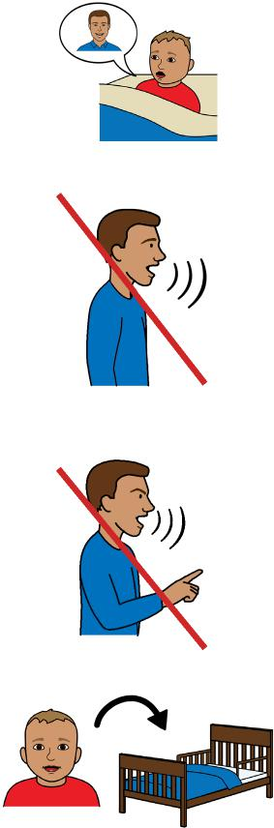

call out.

Do not

* talk
* look them in the eye
* tell them off.

You might put your toddler back to bed a lot of times before they learn to stay.

Page 16

|  |  |
| --- | --- |
|  | If your toddler gets out of bed again tell them you will   * close the door because they did **not** stay in bed |

and

|  |  |
| --- | --- |
|  | * open the door when they **do** stay in bed. |

|  |  |
| --- | --- |
|  | Stay near the door to check your toddler is ok.  Talk to your Maternal and Child Health Nurse for help with calling out first. |

|  |  |
| --- | --- |
|  | It can take 3 days to 3 weeks for a new way to work. |

Page 17

**More information**

For more information contact the Department of Health.

|  |  |
| --- | --- |
|  | Website  [https://www.betterhealth.vic.gov.au/ healthyliving/Child-health-0-6](https://www.betterhealth.vic.gov.au/) |

|  |  |
| --- | --- |
|  | If you are worried about your toddler contact   * your Maternal and Child Health Nurse * call the Maternal and Child Health Line. Call 13 22 29   The helpline is open 24 hours per day and 7 days per week.  You can also see your doctor for more help. |
|  |
| Page 18 |  |

**More Easy English**

|  |  |
| --- | --- |
|  | There are more Easy English books on our website about   * sleep for toddlers |

|  |  |
| --- | --- |
|  | * good sleep routines. |

|  |  |
| --- | --- |
|  | For information about safe sleep go to the Red Nose website  [rednose.org.au/resources/education](http://rednose.org.au/resources/education) |

|  |  |
| --- | --- |
|  | For information about getting to know your child go to the Raising Children website [raisingchildren.net.au/toddlers/connecting-communicating/connecting/parent-child-relationships](http://raisingchildren.net.au/toddlers/connecting-communicating/connecting/parent-child-relationships) |

Page 19

|  |  |
| --- | --- |
|  | **If you need help to speak or listen**  You can use the National Relay Service or  NRS if you need help to make a call. |

|  |  |
| --- | --- |
|  | Call the NRS help desk  1800 555 660  Go to the NRS website  [/www.accesshub.gov.au/about-the-nrs](https://www.accesshub.gov.au/about-the-nrs) |

Page 20

**Notes**

Page 21

**Notes**

Page 22

**Notes**

Page 23

To receive this publication in an accessible format email Maternal and Child Health and Parenting: [MCH@health.vic.gov.au](mailto:MCH%40health.vic.gov.au?subject=).



Authorised and published by the Victorian Government, 1 Treasury Place, Melbourne.

© State of Victoria, Australia, Department of Health, May 2024.

**ISBN** 978-1-76069-222-3

Available at [https://www.betterhealth.vic.gov.au/ healthyliving/Child-health-0-6](https://www.betterhealth.vic.gov.au/%20healthyliving/Child-health-0-6) (pdf/online).

Certain text, images and information incorporated in this publication were created by Scope (Aust) Ltd at [www.scopeaust.org.au](http://www.scopeaust.org.au) and Tobii Dynavox.

Scope (Aust) Ltd produced this Easy English version with the Department of Health in May 2024. The ‘Easy English’ style of writing is © Scope (Aust) Ltd 2024 (“Clear Written Communications - The Easy English Style Guide”). All Rights Reserved Worldwide. To contact Scope about its Easy English style of writing and its services call 1300 472 673 or visit [www.scopeaust.org.au](http://www.scopeaust.org.au)

The following materials contained in this document are not licensed to the State of Victoria, Australia,

Department of Health (‘excluded materials’):

- PCS is a trademark of Tobii Dynavox, LLC. All rights reserved. Used with permission. This document must not

be sold to third parties. The images must not be reused without permission.

- Certain other images and photographs (as marked).

Permission must be obtained from Tobii Dynavox or any other relevant third parties (as applicable) to use, copy,

reproduce, digitise, adapt, modify, communicate or publish any part of the above excluded materials.