`1441MINIII

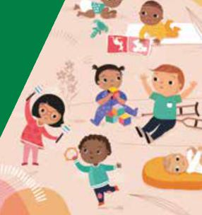

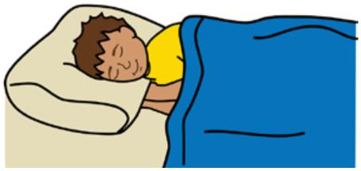

**How preschoolers sleep**

**Preschoolers 3 - 5 years**



**Easy English**

**Hard words**

|  |  |
| --- | --- |
|  | This book has some hard words. |

The first time we write a hard word

* the word is in **blue**
* we write what the hard word means.

**You can get help with this book**

|  |  |
| --- | --- |
|  | You can get someone to help you   * read this book * know what this book is about * find more information. |
|  |

**About this book**

|  |  |
| --- | --- |
|  | This book is written by the  Department of Health. |

|  |  |
| --- | --- |
|  | This book tells you about sleep  for **preschoolers**. |

|  |  |
| --- | --- |
|  | A preschooler is a child aged **3 - 5** years. |

**How much sleep is normal?**

|  |  |
| --- | --- |
|  | Your child will sleep 10 - 13 hours per day. |

|  |  |
| --- | --- |
|  | Your child might **not** always need a day time nap. |

|  |  |
| --- | --- |
|  | Your child might get scared at night.  Your child might   * wake up more |

|  |  |
| --- | --- |
|  | * call out to you * ask to sleep in your bed.   It is up to you to say if your child can sleep in your bed safely. |
|  |

**Bed wetting**

|  |  |
| --- | --- |
|  | Bed wetting means your child does **not** wake up when they need to go to the toilet. |

|  |  |
| --- | --- |
|  | A child might wet the bed because they have a full bladder. |

|  |  |
| --- | --- |
|  | Bed wetting is normal and will go away by itself. |

For more information contact the

|  |  |
| --- | --- |
|  | **More information** |

Department of Health.

|  |  |
| --- | --- |
|  | Website  [https://www.betterhealth.vic.gov.au/ healthyliving/Child-health-0-6](https://www.betterhealth.vic.gov.au/healthyliving/Child-health-0-6) |

|  |  |
| --- | --- |
|  | If you are worried about your child   * contact your Maternal and Child Health Nurse |

* call the Maternal and Child Health Line.

|  |  |
| --- | --- |
|  | Call 13 22 29  The helpline is open 24 hours per day and 7 days per week.  You can also see your doctor for more help. |

**More Easy English**

|  |  |
| --- | --- |
|  | There are more Easy English books on our website about   * good sleep routines |

|  |  |
| --- | --- |
|  | * help for sleep problems. |

|  |  |
| --- | --- |
|  | **If you need help to speak or listen**  You can use the National Relay Service or  NRS if you need help to make a call. |

|  |  |
| --- | --- |
|  | Call the NRS help desk  1800 555 660 |

|  |  |
| --- | --- |
|  | [Go to the NRS website https://](https://www.accesshub.gov.au/about-the-nrs)  [www.accesshub.gov.au/about-the-nrs](https://www.accesshub.gov.au/about-the-nrs) |

To receive this publication in an accessible format email Maternal and Child Health and Parenting: [MCH@health.vic.gov.au](mailto:MCH@health.vic.gov.au).



Authorised and published by the Victorian Government, 1 Treasury Place, Melbourne.

© State of Victoria, Australia, Department of Health, July 2020.

**ISBN** 978-1-76069-222-3

Available at <https://www.betterhealth.vic.gov.au/healthyliving/Child-health-0-6>

Certain text, images and information incorporated in this publication were created by Scope (Aust) Ltd at [www.scopeaust.org.au](http://www.scopeaust.org.au) and Tobii Dynavox.

Scope (Aust) Ltd produced this Easy English version with the Department of Health in December 2020. The ‘Easy English’ style of writing is © Scope (Aust) Ltd 2020 (“Clear Written Communications - The Easy English Style Guide”). All Rights Reserved Worldwide. To contact Scope about its Easy English style of writing and its services call 1300 472 673 or visit [www.scopeaust.org.au](http://www.scopeaust.org.au)

The following materials contained in this document are not licensed to the State of Victoria, Australia,

Department of Health (‘excluded materials’):

- The Picture Communication Symbols ©1981–2020 by Tobii Dynavox. All Rights Reserved Worldwide. Used

with permission. BoardmakerTM is a trademark of Tobii Dynavox.

- Certain other images and photographs (as marked).

Permission must be obtained from Tobii Dynavox or any other relevant third parties (as applicable) to use, copy,

reproduce, digitise, adapt, modify, communicate or publish any part of the above excluded materials.