`1441MINIII

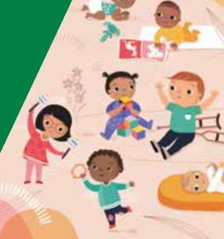

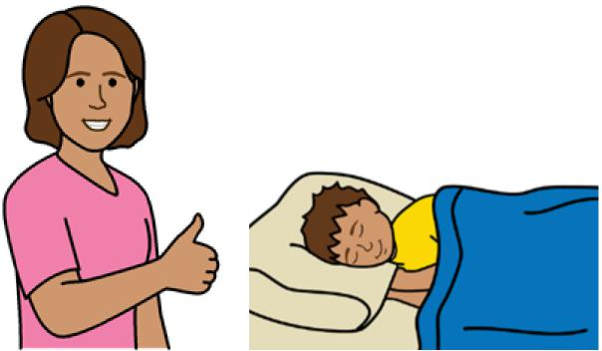

**Good sleep routines**

**Preschoolers 3 - 5 years**



**Easy English**

**Hard words**

|  |  |
| --- | --- |
|  | This book has some hard words. |

~~~~~~~~~~~~~~~~~搀

* the word is in **blue**
* we write what the hard word means.

**You can get help with this book**

|  |  |
| --- | --- |
|  | You can get someone to help you   * read this book * know what this book is about * find more information. |
|  |

**About this book**

|  |  |
| --- | --- |
|  | This book is written by the  Department of Health. |

|  |  |
| --- | --- |
|  | This book tells you about good **sleep routines** for preschoolers aged **3 - 5** years. |

Sleep routines mean things you do to help your toddler sleep each day.

**Get to know your child**

It is important your child knows you are there to care for them.

|  |  |
| --- | --- |
|  | Make sure you   * listen to what your child has to say |

|  |  |
| --- | --- |
|  | * notice **tired signs**. |

Tired signs are the things your child does when they are tired.

Your child might be tired if they had a big day.

|  |  |
| --- | --- |
|  | Tired signs help you know when to put your child to bed. |

When your child is tired they might

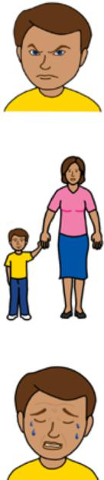

* get grumpy
* want more attention
* make noises or cry
* rub their eyes

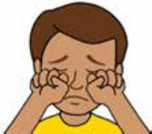

* get bored with toys

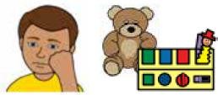

* be fussy with food.

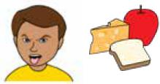

|  |  |
| --- | --- |
|  | **Sleep routines**  Sleep routines help your child know when it is sleep time.  You can do things to help your child know when it is day and night. |

**Day time routines**

Play with your child in the day. For example

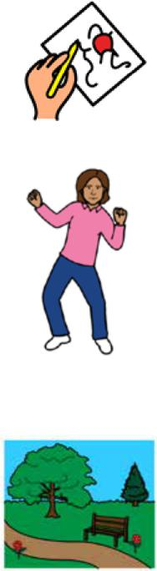

* draw
* dance
* play with a ball
* go to the park.

**Night time sleep routines**

|  |  |
| --- | --- |
|  | Do things to help your child relax at night. For example   * give a bath * read or tell a bed time story. |

|  |  |
| --- | --- |
|  | Make sure sleep routines   * are the same every time |

|  |  |
| --- | --- |
|  | * are short, for example 30 - 45 minutes. |

|  |  |
| --- | --- |
|  | Some routines might be hard to keep up for a long time. |
|  | Your child might fall asleep in your bed every night when you do **not** want them to. |

|  |  |
| --- | --- |
|  | To help your child sleep on their own   * put them in their own bed when you think they are tired |

|  |  |
| --- | --- |
|  | * let them fall asleep on their own. |

|  |  |
| --- | --- |
|  | **Sleep environment**  Keep the **sleep environment** the same.  The sleep environment is the place your toddler sleeps. |

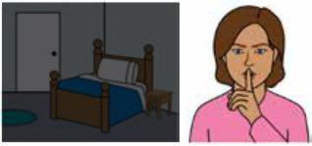

You can

* make it dark and quiet
* turn off screens such as a TV or tablet 30 minutes before sleep time

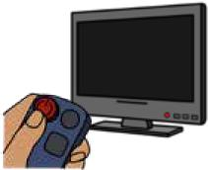

* use the same toys or blankets

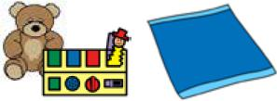

* make sleep and wake times the same time every day.

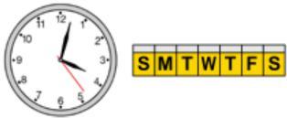

**Safe sleep**

To help your child sleep safe make sure

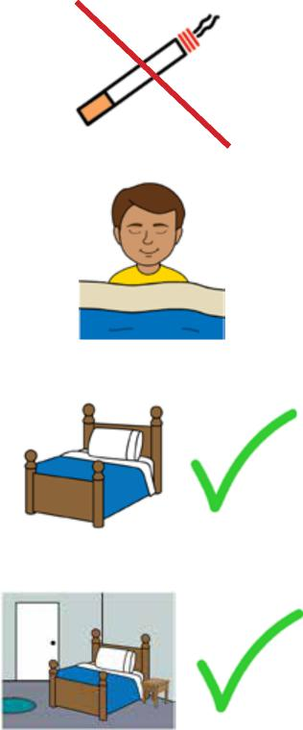

* you do **not** smoke around your child
* nothing covers their face or head
* they have a safe bed
* the room is safe, for example there are **no** cords close by.

|  |  |
| --- | --- |
|  | When you move your child to a bed make sure  the bedroom is safe.  For example   * block off stairs * cover up cords and power points. |

For more information contact the Department of Health and Human Services.

|  |  |
| --- | --- |
|  | **More information** |

|  |  |
| --- | --- |
|  | Website  [https://www.betterhealth.vic.gov.au/ healthyliving/Child-health-0-6](https://www.betterhealth.vic.gov.au/healthyliving/Child-health-0-6) |

|  |  |
| --- | --- |
|  | If you are worried about your child   * contact your Maternal and Child Health Nurse |

* call the Maternal and Child Health Line.

|  |  |
| --- | --- |
|  | Call 13 22 29  The helpline is open 24 hours per day and 7 days per week.  You can also see your doctor for more help. |

**More Easy English**

|  |  |
| --- | --- |
|  | There are more Easy English books on our website about   * sleep for preschoolers |

|  |  |
| --- | --- |
|  | * help for sleep problems. |

|  |  |
| --- | --- |
|  | For information about safe sleep go to the Red Nose website  [rednose.org.au/resources/education](http://rednose.org.au/resources/education) |

|  |  |
| --- | --- |
|  | For information about getting to know your child go to the Raising Children website [raisingchildren.net.au/toddlers/ connecting-communicating/connecting/ parent-child-relationships](https://raisingchildren.net.au/toddlers/connecting-communicating/connecting/parent-child-relationships) |

|  |  |
| --- | --- |
|  | **If you need help to speak or listen**  You can use the National Relay Service or  NRS if you need help to make a call. |

|  |  |
| --- | --- |
|  | Call the NRS help desk  1800 555 660  Go to the NRS website  [communications.gov.au/accesshub/nrs](http://communications.gov.au/accesshub/nrs) |

To receive this publication in an accessible format email Maternal and Child Health and Early Parenting: [MCH@health.vic.gov.au](mailto:MCH@health.vic.gov.au).



Authorised and published by the Victorian Government, 1 Treasury Place, Melbourne.

© State of Victoria, Australia, Department of Health, July 2020.

**ISBN** 978-1-76069-222-3

Available at <https://www.betterhealth.vic.gov.au/healthyliving/Child-health-0-6>

Certain text, images and information incorporated in this publication were created by Scope (Aust) Ltd at [www.scopeaust.org.au](http://www.scopeaust.org.au) and Tobii Dynavox.

Scope (Aust) Ltd produced this Easy English version with the Department of Health in December 2020. The ‘Easy English’ style of writing is © Scope (Aust) Ltd 2020 (“Clear Written Communications - The Easy English Style Guide”). All Rights Reserved Worldwide. To contact Scope about its Easy English style of writing and its services call 1300 472 673 or visit [www.scopeaust.org.au](http://www.scopeaust.org.au)

The following materials contained in this document are not licensed to the State of Victoria, Australia,

Department of Health (‘excluded materials’):

- The Picture Communication Symbols ©1981–2020 by Tobii Dynavox. All Rights Reserved Worldwide. Used

with permission. BoardmakerTM is a trademark of Tobii Dynavox.

- Certain other images and photographs (as marked).

Permission must be obtained from Tobii Dynavox or any other relevant third parties (as applicable) to use, copy,

reproduce, digitise, adapt, modify, communicate or publish any part of the above excluded materials.

