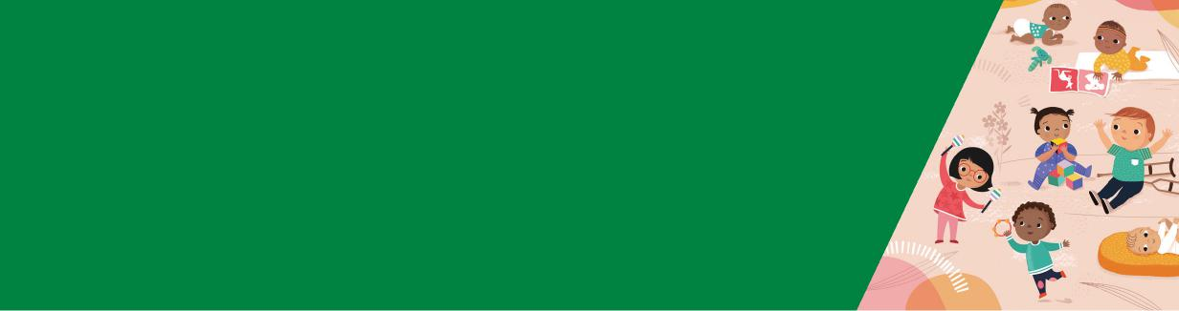

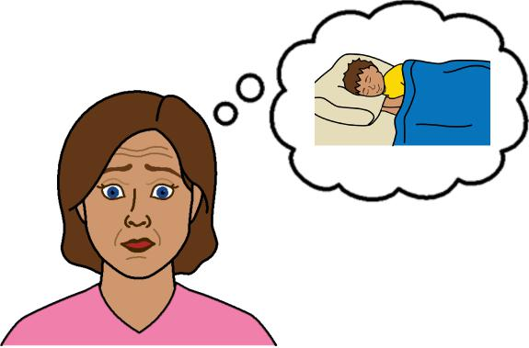

**Help for sleep problems**

**Preschoolers 3 - 5 years**

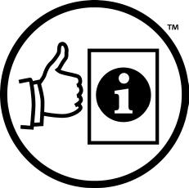

**Easy English**

**Hard words**

|  |  |
| --- | --- |
|  | This book has some hard words. |

The first time we write a hard word

* the word is in **blue**
* we write what the hard word means.

**You can get help with this book**

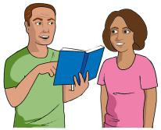

You can get someone to help you

* read this book
* know what this book is about
* find more information.



Page 2

**About this book**

|  |  |
| --- | --- |
|  | This book is written by the  Department of Health |

|  |  |
| --- | --- |
|  | This book tells you about help for  **sleep problems** in preschoolers **3 - 5** years. |

Page 3

**Severe night waking**

**Severe night waking** means your child

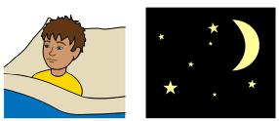

* wakes up more than 3 times per night
* stays awake for more than 20 minutes

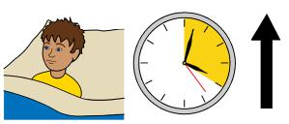

* takes more than 30 minutes to settle

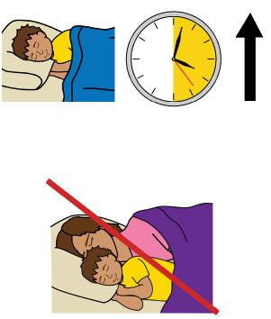

* needs to sleep in bed with you.

Page 4

**Help with sleep concerns**

|  |  |
| --- | --- |
|  | To help your child sleep make sure you   * notice the things they do when they are tired |

|  |  |
| --- | --- |
|  | * put your child in bed when you think they are tired |

|  |  |
| --- | --- |
|  | * do things in the same order every day before sleep time |

|  |  |
| --- | --- |
|  | * keep the room dark and quiet every night before bed. |

Page 5

**Bed time fading**

**Bed time fading** can help your child sleep.

Follow these steps for bed time fading.

|  |  |
| --- | --- |
|  | 1. Write down the time when your child falls asleep for 7 nights in a row. |

2. Find the latest time your child went to sleep in 7 nights and make it the new bed time.

|  |  |
| --- | --- |
|  | 3. Make bed time 15 mins later every 2 days.  4. Stop fading when your toddler goes to sleep on their own and does **not** wake up a lot at night. |

Page 6

Use bed time fading when your child is 2 - 3 years old.

|  |  |
| --- | --- |
|  | You can use bed time fading to make bed time earlier too.  Talk to your Maternal and Child Health Nurse before you try bed time fading. |

Page 7

**Reward chart**

|  |  |
| --- | --- |
|  | A **reward chart** means something good happens when your child does the right thing. |

|  |  |
| --- | --- |
|  | You might put a sticker on a reward chart if your child does **not** call out to you at night. |

|  |  |
| --- | --- |
|  | Do something fun with your child when they get 3 - 5 stickers. |

Something fun might be a movie night.

|  |  |
| --- | --- |
|  | If your child does **not** get a sticker do **not** make them feel bad.  Tell your child   * it is okay if they do **not** get a sticker |

* they can always try to do a better job

next time.

Page 8

**Free pass**

|  |  |
| --- | --- |
|  | A free pass means you let your child get **1** thing they want at bedtime. For example, read a book or give a kiss. |

|  |  |
| --- | --- |
|  | Tell your child after they use the free pass they must   * sleep * **not** ask for anything else. |

|  |  |
| --- | --- |
|  | Ignore your child if they   * call out to you |

* ask for something silly.

A reward chart or free pass only works if your child can

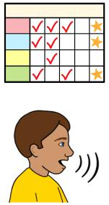

* talk
* understand you. Page 9

**Safe sleep**

|  |  |
| --- | --- |
|  | You must make sure the bedroom is safe. For example   * get a bed that is low to the ground |

|  |  |
| --- | --- |
|  | * cover up cords and power points * block off stairs * lock windows. |

Page 10

|  |  |
| --- | --- |
|  | **More information**  For more information contact the |

Department of Health and Human Services.

|  |  |
| --- | --- |
|  | Website  [https://www.betterhealth.vic.gov.au/ healthyliving/Child-health-0-6](https://www.betterhealth.vic.gov.au/healthyliving/Child-health-0-6) |

If you are worried about your toddler

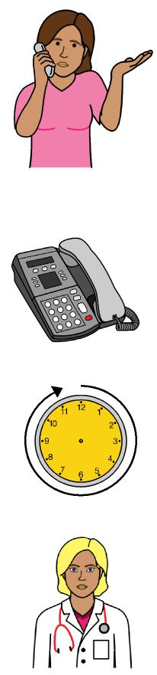

* contact your Maternal and Child Health Nurse
* call the Maternal and Child Health Line. Call 13 22 29

The helpline is open 24 hours per day and 7 days per week.

You can also see your doctor for more help.

Page 11

**More Easy English**

|  |  |
| --- | --- |
|  | There are more Easy English books on our website about   * sleep for preschoolers * good sleep routines. |

|  |  |
| --- | --- |
|  | **If you need help to speak or listen**  You can use the National Relay Service or  NRS if you need help to make a call. |

|  |  |
| --- | --- |
|  | Call the NRS help desk  1800 555 660  Go to the NRS website  www.accesshub.gov.au/about-the-nrs |

Page 12

**Notes**

Page 13

**Notes**

Page 14

**Notes**

Page 15

To receive this publication in an accessible format email Maternal and Child Health and Early Parenting: [MCH@health.vic.gov.au](mailto:MCH@health.vic.gov.au).



Authorised and published by the Victorian Government, 1 Treasury Place, Melbourne.

© State of Victoria, Australia, Department of Health, July 2020.

**ISBN** 978-1-76069-222-3

Available at <https://www.betterhealth.vic.gov.au/healthyliving/Child-health-0-6> (pdf/online).

Certain text, images and information incorporated in this publication were created by Scope (Aust) Ltd at [www.scopeaust.org.au](http://www.scopeaust.org.au) and Tobii Dynavox.

Scope (Aust) Ltd produced this Easy English version with the Department of Health in December 2020. The ‘Easy English’ style of writing is © Scope (Aust) Ltd 2020 (“Clear Written Communications - The Easy English Style Guide”). All Rights Reserved Worldwide. To contact Scope about its Easy English style of writing and its services call 1300 472 673 or visit [www.scopeaust.org.au](http://www.scopeaust.org.au)

The following materials contained in this document are not licensed to the State of Victoria, Australia,

Department of Health (‘excluded materials’):

- The Picture Communication Symbols ©1981–2020 by Tobii Dynavox. All Rights Reserved Worldwide. Used

with permission. BoardmakerTM is a trademark of Tobii Dynavox.

- Certain other images and photographs (as marked).

Permission must be obtained from Tobii Dynavox or any other relevant third parties (as applicable) to use, copy,

reproduce, digitise, adapt, modify, communicate or publish any part of the above excluded materials.