

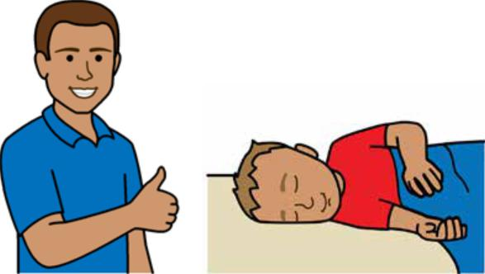

**Good sleep routines**

**Toddlers 1 - 3 years**



**Easy English**

**Hard words**

|  |  |
| --- | --- |
|  | This book has some hard words. |

The first time we write a hard word

* the word is in **blue**
* we write what the hard word means.

**You can get help with this book**

|  |  |
| --- | --- |
|  | You can get someone to help you   * read this book * know what this book is about * find more information. |
|  |

Page 2

**About this book**

|  |  |
| --- | --- |
|  | This book is written by the  Department of Health. |

|  |  |
| --- | --- |
|  | This book tells you about good **sleep routines** for toddlers aged **1 - 3** years |

Sleep routines mean things you do to help your toddler sleep each day.

Page 3

**Get to know your toddler**

**Bonding** is important to help your toddler sleep.

|  |  |
| --- | --- |
|  | Bonding means you   * get to know your toddler * help your toddler feel safe. |

|  |  |
| --- | --- |
|  | Bonding can be hard when your toddler is upset. For example, when your toddler   * can **not** find the way to tell you something |

|  |  |
| --- | --- |
|  | * has **separation anxiety**. |

Separation anxiety means your toddler gets upset when you leave.

Page 4

**Tired signs**

|  |  |
| --- | --- |
|  | Tired signs are the things your toddler does when they are tired. |

When your toddler is tired, they might

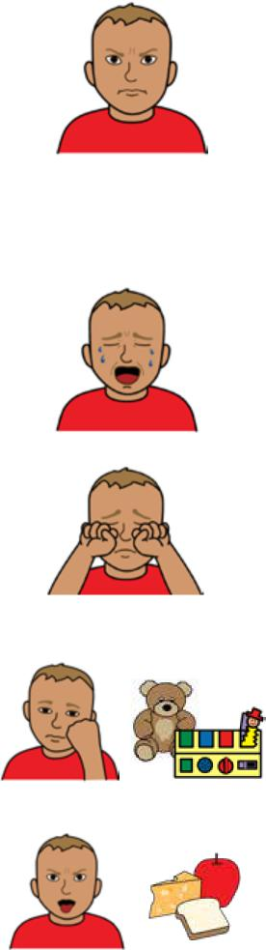

* get grumpy
* want more attention
* make noises or cry
* rub their eyes
* get bored with toys
* be fussy with food.

Page 5

|  |  |
| --- | --- |
|  | Tired signs help you know when to put your toddler in bed to sleep. |
|  | Toddlers might get tired if they miss a nap in the day. |

Page 6

**Sleep routines**

|  |  |
| --- | --- |
|  | Sleep routines help your toddler learn when it is sleep time. |

|  |  |
| --- | --- |
|  | You can do things to help your toddler know when it is day and night. |

**Day time routines**

|  |  |  |
| --- | --- | --- |
|  | Play with your toddler in the day. For example   * draw * dance * play with a ball * go to the park. |  |
|  | Page 7 |

**Night time sleep routines**

|  |  |
| --- | --- |
|  | Do things to help your child relax at night. For example   * give a bath * read or tell a bed time story.   Some routines might be hard to keep up for a long time. |

|  |  |
| --- | --- |
|  | Make sure sleep routines   * are the same every time |

|  |  |
| --- | --- |
|  | * are short, for example 30 - 45 minutes. |

Page 8

|  |  |
| --- | --- |
|  | Your child might fall asleep in your bed every night when you do **not** want them to. |

|  |  |
| --- | --- |
|  | To help your toddler sleep on their own   * put them in bed when you think they are tired |

|  |  |
| --- | --- |
|  | * let them fall asleep on their own. |

Page 9

|  |  |
| --- | --- |
|  | **Sleep environment**  Keep the **sleep environment** the same.  The sleep environment is the place your toddler sleeps. |

|  |  |
| --- | --- |
|  | You can   * make it dark and quiet |

|  |  |
| --- | --- |
|  | * use the same toys or blankets |

|  |  |
| --- | --- |
|  | * make sleep and wake times the same time every day. |

Page 10

**Safe sleep**

To help your toddler sleep safe make sure

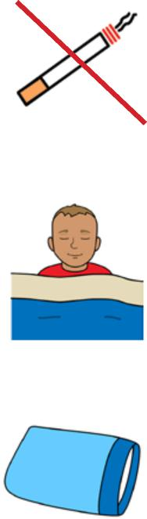

* you do **not** smoke around your toddler
* nothing covers their face or head
* your toddler is 2 years old before they use a pillow

|  |  |
| --- | --- |
|  | * the cot is safe. For example, there are **no** cords close by. |

|  |  |
| --- | --- |
|  | Move your toddler to a bed if they try to get out of the cot. |

Page 11

|  |  |
| --- | --- |
|  | To make the bedroom safe   * cover up cords and power points * block off stairs |

|  |  |
| --- | --- |
|  | Your toddler might move to a bed when they are 1 - 3 years old. |

Page 12

|  |  |
| --- | --- |
|  | If you move your toddler to a bed, make sure the bedroom is safe. |

For more information contact the

|  |  |
| --- | --- |
|  | **More information** |

Department of Health.

|  |  |
| --- | --- |
|  | Website  <https://www.betterhealth.vic.gov.au/healthyliving/child-health-0-6> |

|  |  |
| --- | --- |
|  | If you are worried about your toddler   * contact your Maternal and Child Health Nurse |

* call the Maternal and Child Health Line.

|  |  |
| --- | --- |
|  | Call 13 22 29  The helpline is open 24 hours per day and 7 days per week.  You can also see your doctor for more help.  Page 13 |

**More Easy English**

|  |  |
| --- | --- |
|  | There are more Easy English books on our website about   * sleep for toddlers |

|  |  |
| --- | --- |
|  | * help for sleep problems. |

|  |  |
| --- | --- |
|  | For more information about safe sleep go to the Red Nose website [https://rednose.org.au/resources/ education](https://rednose.org.au/resources/%20education) |

|  |  |
| --- | --- |
|  | For information about bonding go to the Raising Children website <https://raisingchildren.net.au/> |

Page 14

|  |  |
| --- | --- |
|  | **If you need help to speak or listen**  You can use the National Relay Service or  NRS if you need help to make a call. |

|  |  |
| --- | --- |
|  | Call the NRS help desk  1800 555 660  Go to the NRS website  [communications.gov.au/accesshub/nrs](http://communications.gov.au/accesshub/nrs) |

Page 15

To receive this publication in an accessible format email Maternal and Child Health and Early Parenting: [MCH@health.vic.gov.au](mailto:MCH@health.vic.gov.au).



Authorised and published by the Victorian Government, 1 Treasury Place, Melbourne.

© State of Victoria, Australia, Department of Health, July 2020.

**ISBN** 978-1-76069-222-3

Available at <https://www.betterhealth.vic.gov.au/healthyliving/child-health-0-6> (pdf/online).

Certain text, images and information incorporated in this publication were created by Scope (Aust) Ltd at [www.scopeaust.org.au](http://www.scopeaust.org.au) and Tobii Dynavox.

Scope (Aust) Ltd produced this Easy English version with the Department of Health in December 2020. The ‘Easy English’ style of writing is © Scope (Aust) Ltd 2020 (“Clear Written Communications - The Easy English Style Guide”). All Rights Reserved Worldwide. To contact Scope about its Easy English style of writing and its services call 1300 472 673 or visit [www.scopeaust.org.au](http://www.scopeaust.org.au)

The following materials contained in this document are not licensed to the State of Victoria, Australia,

Department of Health (‘excluded materials’):

- The Picture Communication Symbols ©1981–2020 by Tobii Dynavox. All Rights Reserved Worldwide. Used

with permission. BoardmakerTM is a trademark of Tobii Dynavox.

- Certain other images and photographs (as marked).

Permission must be obtained from Tobii Dynavox or any other relevant third parties (as applicable) to use, copy,

reproduce, digitise, adapt, modify, communicate or publish any part of the above excluded materials.