|  |
| --- |
| **Ak -gm=**  **°D4i1U**  **ALI**  **In. ill**  **kijih** |

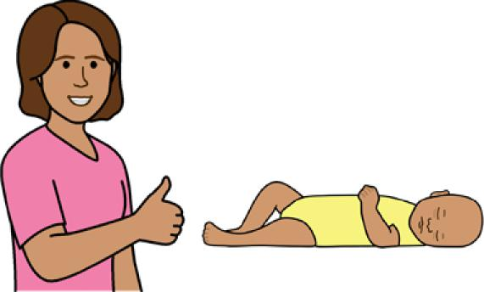

**Good sleep routines**

**Babies 6 - 12 months**



**Easy English**

**Hard words**

|  |  |
| --- | --- |
|  | This book has some hard words. |

The first time we write a hard word

* the word is in **blue**
* we write what the hard word means.

**You can get help with this book**

|  |  |
| --- | --- |
|  | You can get someone to help you   * read this book * know what this book is about * find more information. |
|  |

Page 2

**About this book**

|  |  |
| --- | --- |
|  | This book is written by the  Department of Health. |

|  |  |
| --- | --- |
|  | This book tells you about good **sleep routines** for babies aged **6 - 12** months. |

Sleep routines mean things you do to help your baby sleep each day.

Page 3

**Get to know your baby**

**Bonding** is important to help your baby sleep.

|  |  |
| --- | --- |
|  | Bonding means you   * get to know your baby * help your baby feel safe. |

|  |  |
| --- | --- |
|  | Your baby might start to bond with other people and things. For example, your friends or toys. |

|  |  |
| --- | --- |
|  | Make sure you   * play with your baby * talk and sing to your baby * look your baby in the eyes. |
| Page 4 |  |

**Responsive settling**

|  |  |
| --- | --- |
|  | **Responsive settling** means you help your baby sleep and settle. |

|  |  |
| --- | --- |
|  | To help settle your baby you can try   * gentle pats or strokes |

|  |  |
| --- | --- |
|  | * quiet noises like shushing * a walk in the pram * cuddles. |

Page 5

|  |  |
| --- | --- |
|  | If the way you settle your baby does **not** work  after 5 - 10 minutes, change to  something else. |

|  |  |
| --- | --- |
|  | Try one idea at a time for up to 10 minutes until your baby settles. |

|  |  |
| --- | --- |
|  | To help your baby settle, check your baby   * has a clean nappy * is fed * is **not** too hot or cold. |

Page 6

|  |  |
| --- | --- |
|  | If your baby will **not** stop crying and you are tired   * take a break for 3 - 5 minutes |

|  |  |
| --- | --- |
|  | * put your baby in the cot where they can cry in a safe place. |

|  |  |
| --- | --- |
|  | You must rest and look after yourself too. |

Page 7

**Tired signs**

Tired signs are the things your baby does

when they are tired.

For example, your baby might

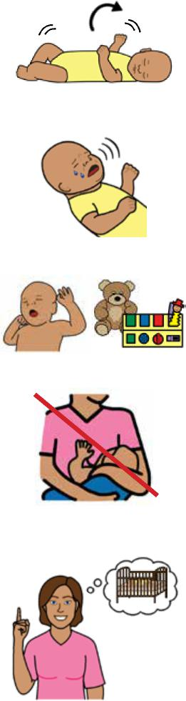

* move around a lot
* make noises or cry
* get bored with toys
* **not** want to eat.

Tired signs help you know when to put your baby in the cot to sleep.

|  |  |
| --- | --- |
|  | Your baby will get tired if they are awake for 2 - 3 hours. |
| Page 8 |  |

**Sleep routines**

|  |  |
| --- | --- |
|  | **Sleep routines** means you do things in the same order every day before sleep time.  Sleep routines help your baby learn when it is sleep time. |

**Day time sleep routines**

|  |  |
| --- | --- |
|  | Sleep routines in the day might mean you   * feed your baby |

|  |  |
| --- | --- |
|  | * play with your baby, for example, floor time or a song |

|  |  |
| --- | --- |
|  | * put your baby in the cot when you think they   are tired.  Page 9 |

**Night time sleep routines**

|  |  |
| --- | --- |
|  | Do things to help your baby relax at night. For example   * do **not** play * give a bath * read or tell a bed time story. |

|  |  |
| --- | --- |
|  | Make sure sleep routines   * are the same every time |

|  |  |
| --- | --- |
|  | * are short, for example 15 - 30 minutes. |

Page 10

|  |  |
| --- | --- |
|  | **Sleep environment**  Keep the **sleep environment** the same.  The sleep environment is the place your baby sleeps. |

|  |  |
| --- | --- |
|  | You can   * make it dark and quiet |

|  |  |
| --- | --- |
|  | * turn off screens such as a TV or tablet 30 minutes before sleep time * have a bath at night * make sleep and wake times the same time every day. |

Page 11

|  |  |
| --- | --- |
|  | **Self settling**  Sleep routines help your baby **self settle**.  Self settle means your baby learns to sleep and settle on their own. |

|  |  |
| --- | --- |
|  | If you hold your baby every time until they sleep, your baby may **not** learn to self settle. |

|  |  |
| --- | --- |
|  | To help your baby self settle   * put them in a cot when you think they are tired |

|  |  |
| --- | --- |
|  | * let your baby sleep on their own. |

|  |  |
| --- | --- |
|  | Your baby will still wake for feeding and nappy changes. |

Page 12

**Safe sleep**

|  |  |  |
| --- | --- | --- |
|  | * **not** in bed with you. | Page 13 |

To help your baby sleep safely make sure

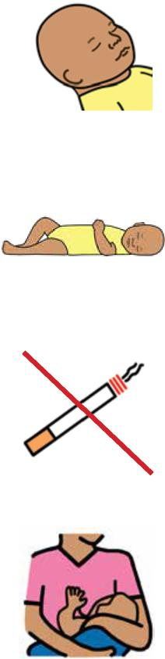

* nothing covers their head or face
* your baby sleeps on their back
* you do **not** smoke around your baby
* you breastfeed your baby.

|  |  |
| --- | --- |
|  | Make sure your baby sleeps in a safe place. For example   * in a cot near your bed |

For more information contact the Department of Health.

|  |  |
| --- | --- |
|  | **More information** |

|  |  |
| --- | --- |
|  | Website  <https://www.betterhealth.vic.gov.au/healthyliving/child-health-0-6> |

|  |  |
| --- | --- |
|  | If you are worried about your baby   * contact your Maternal and Child Health Nurse |

* call the Maternal and Child Health Line.

|  |  |
| --- | --- |
|  | Call 13 22 29  The helpline is open 24 hours per day and 7 days per week.  You can also see your doctor for more help. |
| Page 14 |  |

**More Easy English**

|  |  |
| --- | --- |
|  | There are more Easy English books on our website about   * sleep for babies |

|  |  |
| --- | --- |
|  | * help for sleep problems. |

|  |  |
| --- | --- |
|  | For more information about safe sleep go to the Red Nose website  [https://rednose.org.au/resources/ education](https://rednose.org.au/resources/%20education) |

|  |  |
| --- | --- |
|  | For information about bonding go to the Raising Children website [https://raisingchildren.net.au/babies/](https://raisingchildren.net.au/babies/connecting-communicating/bonding-babies)  [connecting-communicating/bonding-babies](https://raisingchildren.net.au/babies/connecting-communicating/bonding-babies) |

Page 15

|  |  |
| --- | --- |
|  | **If you need help to speak or listen**  You can use the National Relay Service or  NRS if you need help to make a call. |

|  |  |
| --- | --- |
|  | Call the NRS help desk  1800 555 660  [Go to the NRS website https://](https://www.accesshub.gov.au/about-the-nrs)  [www.accesshub.gov.au/about-the-nrs](https://www.accesshub.gov.au/about-the-nrs) |

Page 16

**Notes**

Page 17

**Notes**

Page 18

**Notes**

Page 19

To receive this publication in an accessible format email Maternal and Child Health and Early Parenting: [MCH@health.vic.gov.au](http://MCH@health.vic.gov.au).



Authorised and published by the Victorian Government, 1 Treasury Place, Melbourne.

© State of Victoria, Australia, Department of Health, July 2020.

**ISBN** 978-1-76069-222-3

Available at <https://www.betterhealth.vic.gov.au/healthyliving/child-health-0-6> (pdf/online).

Certain text, images and information incorporated in this publication were created by Scope (Aust) Ltd at [www.scopeaust.org.au](http://www.scopeaust.org.au) and Tobii Dynavox.

Scope (Aust) Ltd produced this Easy English version with the Department of Health in December 2020. The ‘Easy English’ style of writing is © Scope (Aust) Ltd 2020 (“Clear Written Communications - The Easy English Style Guide”). All Rights Reserved Worldwide. To contact Scope about its Easy English style of writing and its services call 1300 472 673 or visit [www.scopeaust.org.au](http://www.scopeaust.org.au)

The following materials contained in this document are not licensed to the State of Victoria, Australia,

Department of Health (‘excluded materials’):

- The Picture Communication Symbols ©1981–2019 by Tobii Dynavox. All Rights Reserved Worldwide. Used

with permission. BoardmakerTM is a trademark of Tobii Dynavox.

- Certain other images and photographs (as marked).

Permission must be obtained from Tobii Dynavox or any other relevant third parties (as applicable) to use, copy,

reproduce, digitise, adapt, modify, communicate or publish any part of the above excluded materials.